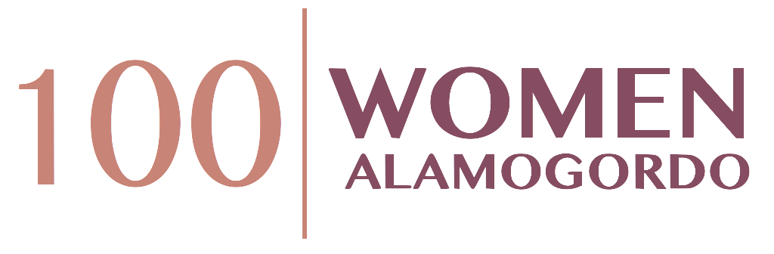

100(+) Women Who Care Alamogordo
Individual Commitment Form

Please Type or Print Clearly

Name:
Street Address:
City, State & Zip:
Telephone (H) (W) (C)
Email Address:

Commitment Year:

I understand that I am making a commitment to 100+ Women Who Care –to make an annual donation of $400 – ($100 at each quarterly meeting) – given directly to local charities, non-profits and other worthy causes serving the Alamogordo area. I understand that even if I did not vote for the charity chosen by majority vote, I will fulfill my donation commitment. I also understand that if I am not able to attend a quarterly meeting that I will provide my check to either another member to deliver or mail in advance of the meeting.

_____________________________________________ ________________
Signature Date

I agree to have my contact information included in the 100+ WWC Membership Directory. Please check: Yes No

Completed Commitment Forms may be scanned and sent via e-mail to french_renee@hotmail.com, or mailed to Renee French at PO Box 432, Alamogordo, NM, 88311. Should you wish to discontinue membership at any time, please send an e-mail to the above address indicating your withdrawal. The 100+ Women Who Care Alamogordo thank you for your support!

