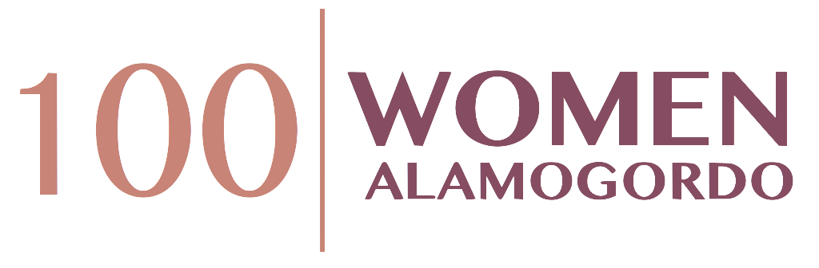

100(+) Women Who Care Alamogordo
2 Person Team Commitment Form

Please Type or Print Clearly

Name:
Street Address:
City, State & Zip:
Telephone (H) (W) (C)
Email Address:

Name:
Street Address:
City, State & Zip:
Telephone (H) (W) (C)
Email Address:

Commitment Year:

We understand that we are making a commitment to 100+ Women Who Care –to make an annual donation of $400 – ($50 per person at each quarterly meeting) – given directly to local charities, non-profits and other worthy causes serving the Alamogordo area. We understand that even if we did not vote for the charity chosen by majority vote, we will fulfill our donation commitment. We also understand that if we are not able to attend a quarterly meeting that we will provide our checks to either another member to deliver or mail in advance of the meeting.

_____________________________________________ ________________
Signature Date

_____________________________________________ ________________
Signature Date

We agree to have our contact information included in the 100+ WWC Membership Directory. Please check: Yes No

Completed Commitment Forms may be scanned and sent via e-mail to french_renee@hotmail.com, or mailed to Renee French at PO Box 432, Alamogordo, NM, 88311. Should you wish to discontinue membership at any time, please send an e-mail to the above address indicating your withdrawal. The 100+ Women Who Care Alamogordo thank you for your support!

